PART I CUL ARS OF ST AFF
Name and address of the Institution: Rao Dalip Singh College of Education, Mumtajpur Post–Baspadmka Distt–Gurgaon (Hr) Course: B.Ed.

Sr.No. | Name with Date of Birth | Photograph of the appointed staff | Designation | B.Ed.  Yes/N o | M.Ed.  Yes/No | M.A  (Education) Yes/No | Master’s Degree in school  subject Yes/No | Ph.D.  (Education/ Specify the subject) Yes/No | Passed UGC NET or equivalent Yes/No | Subject of Pedagogy
1. | Dr.Hari Prasad | 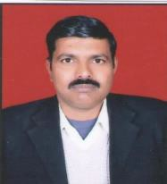 | Principal | Yes | Yes | No | Yes | Yes | Yes | Pedagogy of Commerce
2. | Mrs. Sarul | 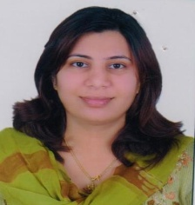 | Assistant Professor | Yes | Yes | No | Yes | No | Yes | Perspective in Education
3. | Mr. Srinivas Azad | 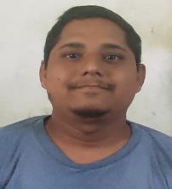 | Assistant Professor | Yes | Yes | No | Yes | No | Yes | Pedagogy of English
4.. | Mr. Vijay Signgh Yadav |  | Assistant Professor | No | No | No | Yes | No | No | Music

5.. | Mr. Kamlesh Yadav | 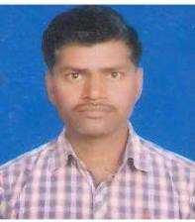 | Assistant Professor | No | No | No | Yes | No | No | Health and Physical Education
6.. | Mr. Vishvanath Kashyap | 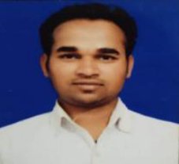 | Assistant Professor | No | No | No | Yes | No | No | Fine Arts
7.. | Mrs. Monika Chaudhary | 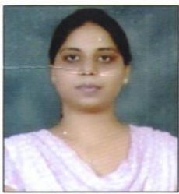 | Assistant Professor | Yes | Yes | No | Yes | No | Yes | Pedagogy of Social Science
8. | Mr. Avinash Dewal |  | Assistant Professor | Yes | Yes | No | Yes | No | Yes | Pedagogy of Mathematics
9. | Mr. Prem Chand Singh |  | Assistant Professor | Yes | Yes | No | Yes | No | Yes | Pedagogy of Sanskrit
10. | Dr. Bhagwan Singh |  | Assistant Professor | No | No | Yes | Yes | Yes | No | Perspective in Education
11. | Dr. Ankit Yadav | 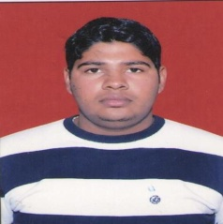 | Assistant Professor | Yes | Yes | No | Yes | Yes | No | Perspective in Education

12. | Mrs, Suman | 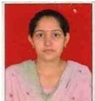 | Librarian |  |  |  |  |  |  | Librarian
13. | Mr. Anoop Singh | 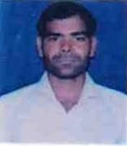 | Head Clerk |  |  |  |  |  |  | Head Clerk
14. | Mrs.Lalita | 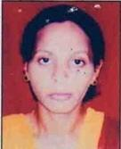 | Clerk |  |  |  |  |  |  | Clerk
15. | Mrs. Poonam | 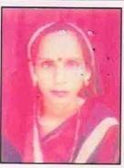 | Library  Attendant |  |  |  |  |  |  | Library Attendant
16. | Mrs. Rekha | 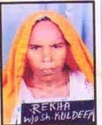 | Sweeper |  |  |  |  |  |  | Sweeper
17. | Mrs. Reena | 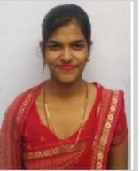 | Asst. Clerk |  |  |  |  |  |  | Asst. Clerk
18. | Mr. Santu | 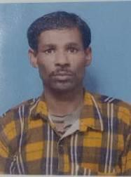 | Sweeper |  |  |  |  |  |  | Sweeper
19. | Mrs. Kavita Bai Bansal | 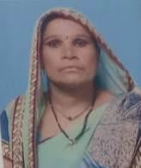 | Peon |  |  |  |  |  |  | Peon

